***Chemistry***

**14: Acid-Base Equilibria**

**14.3: Relative Strengths of Acids and Bases**

27. Explain why the neutralization reaction of a weak acid and a strong base gives a weakly basic solution.

Solution

The salt ionizes in solution, but the anion slightly reacts with water to form the weak acid. This reaction also forms OH–, which causes the solution to be basic. An example is NaCN. The CN– reacts with water as follows: 

29. The odor of vinegar is due to the presence of acetic acid, CH3CO2H, a weak acid. List, in order of descending concentration, all of the ionic and molecular species present in a 1-*M* aqueous solution of this acid.

Solution

[H2O] > [CH3CO2H] > ≈ > [OH–]

31. Explain why the ionization constant, *K*a, for H2SO4 is larger than the ionization constant for H2SO3.

Solution

The oxidation state of the sulfur in H2SO4 is greater than the oxidation state of the sulfur in H2SO3.

33. Gastric juice, the digestive fluid produced in the stomach, contains hydrochloric acid, HCl. Milk of Magnesia, a suspension of solid Mg(OH)2 in an aqueous medium, is sometimes used to neutralize excess stomach acid. Write a complete balanced equation for the neutralization reaction, and identify the conjugate acid-base pairs.

Solution



35. What is the ionization constant at 25 °C for the weak acid , the conjugate acid of the weak base CH3NH2, *K*b = 4.4  10–4.

Solution

*K*w = *K*a × *K*b

**

37. Which base, CH3NH2 or (CH3)2NH, is the strongest base? Which conjugate acid, or  is the strongest acid?

Solution

The strongest base or strongest acid is the one with the larger *K*b or *K*a, respectively. In these two examples, they are (CH3)2NH and .

39. Which is the stronger base, (CH3)3N or ?

Solution

Look up (Appendix I) the value of *K*b for (CH3)3N and the value of *K*a for H3BO3. From the latter, calculate the value of *K*b for . Then compare values:

*K*b(CH3)3N = 6.3  10–5

, 

A comparison shows that the larger *K*b is that of triethylamine.

41. Predict which compound in each of the following pairs of compounds is more acidic and explain your reasoning for each.

(a)  or 

(b) NH3 or H2O

(c) PH3 or HI

(d) NH3 or PH3

(e) H2S or HBr

Solution

(a) ; higher electronegativity of the central ion. (b) H2O; NH3 is a base and water is neutral, or decide on the basis of *K*a values. (c) HI; PH3 is weaker than HCl; HCl is weaker than HI. Thus, PH3 is weaker than HI. (d) PH3; in binary compounds of hydrogen with nonmetals, the acidity increases for the element lower in a group. (e) HBr; in a period, the acidity increases from left to right; in a group, it increases from top to bottom. Br is to the left and below S, so HBr is the stronger acid.

43. Rank the compounds in each of the following groups in order of increasing acidity or basicity, as indicated, and explain the order you assign.

(a) acidity: NaHSO3, NaHSeO3, NaHSO4

(b) basicity: , , 

(c) acidity: HOCl, HOBr, HOI

(d) acidity: HOCl, HOClO, HOClO2, HOClO3

(e) basicity: , HS–, HTe–, 

(f) basicity: BrO–, , , 

Solution

(a) NaHSeO3 < NaHSO3 < NaHSO4; in polyoxy acids, the more electronegative central element—S, in this case—forms the stronger acid. The larger number of oxygen atoms on the central atom (giving it a higher oxidation state) also creates a greater release of hydrogen atoms, resulting in a stronger acid. As a salt, the acidity increases in the same manner. (b) ; the basicity of the anions in a series of acids will be the opposite of the acidity in their oxyacids. The acidity increases as the electronegativity of the central atom increases. Cl is more electronegative than Br, and I is the least electronegative of the three. (c) HOI < HOBr < HOCl; in a series of the same form of oxyacids, the acidity increases as the electronegativity of the central atom increases. Cl is more electronegative than Br, and I is the least electronegative of the three. (d) HOCl < HOClO < HOClO2 < HOClO3; in a series of oxyacids of the same central element, the acidity increases as the number of oxygen atoms increases (or as the oxidation state of the central atom increases). (e) ;  and  are anions of weak bases, so they act as strong bases toward H+. HTe– and HS– are anions of weak acids, so they have less basic character. In a periodic group, the more electronegative element has the more basic anion. (f) ; with a larger number of oxygen atoms (that is, as the oxidation state of the central ion increases), the corresponding acid becomes more acidic and the anion consequently less basic.

45. The active ingredient formed by aspirin in the body is salicylic acid, C6H4OH(CO2H). The carboxyl group (–CO2H) acts as a weak acid. The phenol group (an OH group bonded to an aromatic ring) also acts as an acid but a much weaker acid. List, in order of descending concentration, all of the ionic and molecular species present in a 0.001-*M* aqueous solution of C6H4OH(CO2H).

Solution



47. Explain why equilibrium calculations are not necessary to determine ionic concentrations in solutions of certain strong electrolytes such as NaOH and HCl. Under what conditions are equilibrium calculations necessary as part of the determination of the concentrations of all ions of some other strong electrolytes in solution?

Solution

Strong electrolytes are 100% ionized, and, as long as the component ions are neither weak acids nor weak bases, the ionic species present result from the dissociation of the strong electrolyte. Equilibrium calculations are necessary when one (or more) of the ions is a weak acid or a weak base.

49. What two common assumptions can simplify calculation of equilibrium concentrations in a solution of a weak acid?

Solution

1. Assume that the change in initial concentration of the acid as the equilibrium is established can be neglected, so this concentration can be assumed constant and equal to the initial value of the total acid concentration. 2. Assume we can neglect the contribution of water to the equilibrium concentration of .

51. Which of the following will increase the percent of NH3 that is converted to the ammonium ion in water (Hint: Use LeChâtelier’s principle.)?

(a) addition of NaOH

(b) addition of HCl

(c) addition of NH4Cl

Solution

The equilibrium is:



(a) The addition of NaOH adds OH– to the system and, according to LeChâtelier’s principle, the equilibrium will shift to the left. Thus, the percent of converted NH3 will decrease. (b) The addition of HCl will add  ions, which will then react with the OH– ions. Thus, the equilibrium will shift to the right, and the percent will increase. (c) The addition of NH4­Cl adds  ions, shifting the equilibrium to the left. Thus, the percent will decrease.

53. What is the effect on the concentrations of , HNO2, and OH– when the following are added to a solution of KNO2 in water:

(a) HCl

(b) HNO2

(c) NaOH

(d) NaCl

(e) KNO

The equation for the equilibrium is:



Solution

(a) Adding HCl will add  ions, which will then react with the OH– ions, lowering their concentration. The equilibrium will shift to the right, increasing the concentration of HNO2, and decreasing the concentration of  ions. (b) Adding HNO2 increases the concentration of HNO2 and shifts the equilibrium to the left, increasing the concentration of  ions and decreasing the concentration of OH– ions. (c) Adding NaOH adds OH– ions, which shifts the equilibrium to the left, increasing the concentration of ions and decreasing the concentrations of HNO2. (d) Adding NaCl has no effect on the concentrations of the ions. (e) Adding KNO2 adds  ions and shifts the equilibrium to the right, increasing the HNO2 and OH– ion concentrations.

55. Why is the hydronium ion concentration in a solution that is 0.10 *M* in HCl and 0.10 *M* in HCOOH determined by the concentration of HCl?

Solution

The equations of the occurring chemical processes are:





This is a case in which the solution contains a mixture of acids of different ionization strengths. In solution, the HCO2H exists primarily as HCO2H molecules because the ionization of the weak acid is suppressed by the strong acid. Therefore, the HCO2H contributes a negligible amount of hydronium ions to the solution. The stronger acid, HCl, is the dominant producer of hydronium ions because it is completely ionized. In such a solution, the stronger acid determines the concentration of hydronium ions, and the ionization of the weaker acid is fixed by the  produced by the stronger acid.

57. From the equilibrium concentrations given, calculate *K*a for each of the weak acids and *K*b for each of the weak bases.

(a) NH3: [OH–] = 3.1  10–3 *M*;

 = 3.1  10–3 *M*;

[NH3] = 0.533 *M*;

(b) HNO2:  = 0.011 *M*;

 = 0.0438 *M*;

[HNO2] = 1.07 *M*;

(c) (CH3)3N: [(CH3)3N] = 0.25 *M*;

 = 4.3  10–3 *M*;

[OH–] = 4.3  10–3 *M*;

(d) :  = 0.100 *M*;

[NH3] = 7.5  10–6*M*;

 = 7.5  10–6*M*

Solution

(a) The reaction is 

;

(b) The reaction is 

;

(c) The reaction is 

;

(d) The reaction is 



59. Determine *K*a for hydrogen sulfate ion, . In a 0.10-*M* solution the acid is 29% ionized.

Solution

The reaction is .

The concentrations at equilibrium are:

 = = (0.29)(0.10 *M*) = 0.029 *M*

 = 0.10 *M* – 0.029 *M* = 0.071 *M*



61. Calculate the ionization constant for each of the following acids or bases from the ionization constant of its conjugate base or conjugate acid:

(a) HTe– (as a base)

(b) 

(c)  (as a base)

(d)  (as a base)

(e) 

(f)  (as a base)

Solution

(a) ; (b) ; (c) ;

(d) ; (e) ;

(f) 

63. Even though both NH3 and C6H5NH2 are weak bases, NH3 is a much stronger acid than C6H5NH2. Which of the following is correct at equilibrium for a solution that is initially 0.10 *M* in NH3 and 0.10 *M* in C6H5NH2?

(a) 

(b) 

(c) 

(d) [NH3] = [C6H5NH2]

(e) both a and b are correct

Solution

The reactions are:



Because NH3 is much stronger than C6H5NH2, it dissociates more. As the initial concentrations of both bases are the same, at equilibrium, [NH3] < [C6H5NH2],  > , and [OH–] > . Therefore, (a) is the correct statement. The contribution to the total [OH–] at equilibrium from C6H5NH2 is negligible compared to HN3. Therefore .

65. Calculate the equilibrium concentration of the nonionized acids and all ions in a solution that is 0.134 *M* in HNO2 and 0.120 *M* in HBrO.

Solution

The reactions and equilibrium constants are:



As *K*a is much larger for HNO2 than for HBrO, the first equilibrium will dominate. The equilibrium expression is 

The initial and equilibrium concentrations for this system can be written as follows:

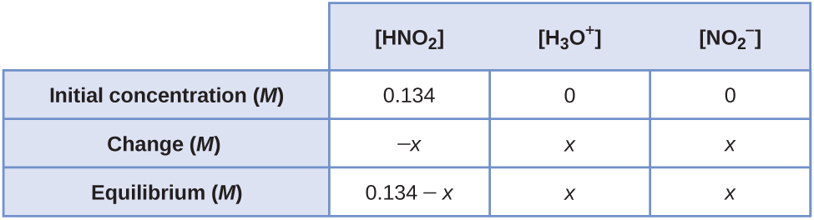

Substituting the equilibrium concentrations into the equilibrium expression and making the assumption that (0.134 – *x*) ≈ 0.134 gives:

Solving for *x* gives 7.77 × 10–3*M*. Because this value is 5.8% of 0.134, our assumption is incorrect. Therefore, we must use the quadratic formula. Using the data gives the following equation:*x*2 + 4.5 × 10–7*x* – 6.03 × 10–5 = 0

Using the quadratic formula gives (*a* = 1, *b* = 4.5 × 10–4, and *c* = –6.03 × 10–5)



The equilibrium concentrations are therefore:



[HNO2] = 0.134 – 7.52  10–3 = 0.1265 = 0.127

[OH–] can be calculated using *K*w:



Finally, use the other equilibrium to find the other concentrations. Assume for [HBrO] that (0.120 – *x*) ≈ 0.120 *M*.



Solving for [BrO–] gives:

[BrO–] = 4.5 10–8 = 4.5  10–8 *M*

[HBrO] = 0.120 – 4.5  10–8 = 0.120 *M*

67. Calculate the equilibrium concentration of the nonionized bases and all ions in a solution that is 0.115 *M* in NH3 and 0.100 *M* in C6H5NH2.

Solution

The reactions and equilibrium constants are:



As *K*b is much larger for NH3 than for C6H5NH2, the first equilibrium will dominate. The equilibrium expression is 

The initial and equilibrium concentrations for this system can be written as follows:

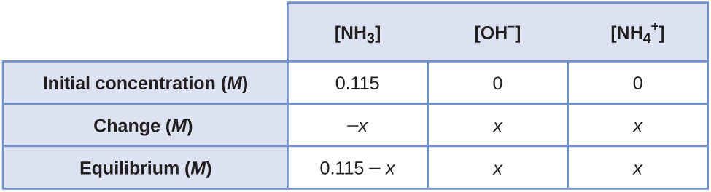

Substituting the equilibrium concentrations into the equilibrium expression and making the assumption that (0.115 – *x*) ≈ 0.115 gives:



Solving for *x* gives 1.44  10–3*M*. Because this value is less than 5% of 0.115 *M*, our assumption is correct. The equilibrium concentrations are therefore:

[OH–] =  = 1.44  10–3 = 0.0014 *M*

[NH3] = 0.115 – 0.00144 = 0.1136 = 0.144 *M*

can be calculated using *K*w:



Finally, use the other equilibrium to find the other concentrations. Assume for [C6H5NH2] that (0.100 – *x*) ≈ 0.100 *M*:



Solving for  gives:

 = 2.99  10–8*M*

[C6H5NH2] = 0.100 – 2.99  10–8 = 0.100 *M*

69. Calculate the concentration of all solute species in each of the following solutions of acids or bases. Assume that the ionization of water can be neglected, and show that the change in the initial concentrations can be neglected. Ionization constants can be found in Appendix H and Appendix I.

(a) 0.0092 *M* HClO, a weak acid

(b) 0.0784 *M* C6H5NH2, a weak base

(c) 0.0810 *M* HCN, a weak acid

(d) 0.11 *M* (CH3)3N, a weak base

(e) 0.120 *M*  a weak acid, *K*a = 1.6  10–7

Solution

(a) The reaction is: 

The equilibrium expression is:



The initial and equilibrium concentrations for this system can be written as follows:

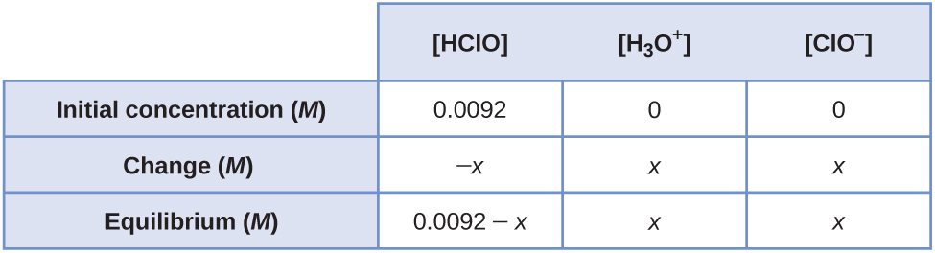

Substituting the equilibrium concentrations into the equilibrium expression and making the assumption that (0.0092 – *x*) ≈ 0.0092 gives:



Solving for *x* gives 1.63  10–5*M*. This value is less than 5% of 0.0092, so the assumption that it can be neglected is valid. Thus, the concentrations of solute species at equilibrium are:

= [ClO] = 1.6  10–5*M*

[HClO] = 0.0092 – 1.63  10–5 = 0.00918 = 0.00092 *M*

;

(b) The reaction is: 

The equilibrium expression is:



The initial and equilibrium concentrations for this system can be written as follows:

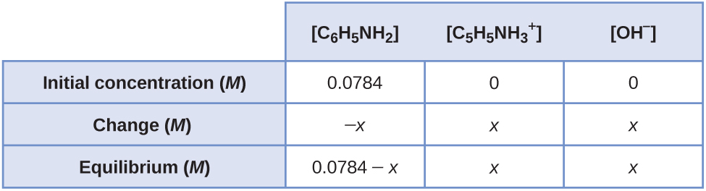

Substituting the equilibrium concentrations into the equilibrium expression and making the assumption that (0.0784 – *x*) ≈ 0.0784 gives:



Solving for *x* gives 5.81  10–6 *M*. This value is less than 5% of 0.0784, so the assumption that it can be neglected is valid. Thus, the concentrations of solute species at equilibrium are:

= [OH–] = 5.8  10–6 *M*

[C6H5NH2] = 0.0784 – 5.81  10–6 = 0.007839 = 0.00784

;

(c) The reaction is .

The equilibrium expression is:



The initial and equilibrium concentrations for this system can be written as follows:

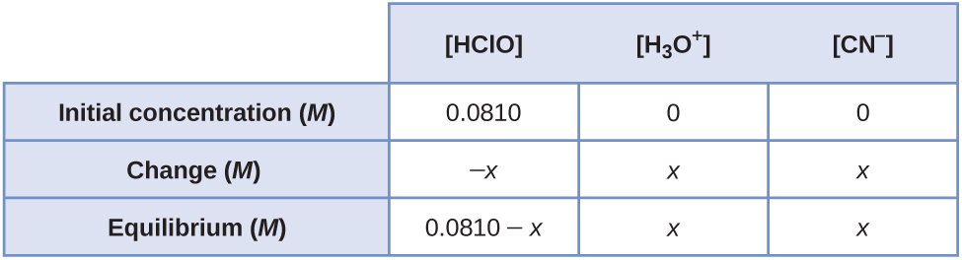

Substituting the equilibrium concentrations into the equilibrium expression and making the assumption that (0.0810 – *x*) ≈ 0.0810 gives:



Solving for *x* gives 6.30  10–6 *M*. This value is less than 5% of 0.0810, so the assumption that it can be neglected is valid. Thus, the concentrations of solute species at equilibrium are:

= [CN–] = 6.3  10–6 *M*

[HCN] = 0.0810 – 6.30  10–6 = 0.08099 = 0.0810 *M*

;

(d) The reaction is:



The equilibrium expression is:



The initial and equilibrium concentrations for this system can be written as follows:

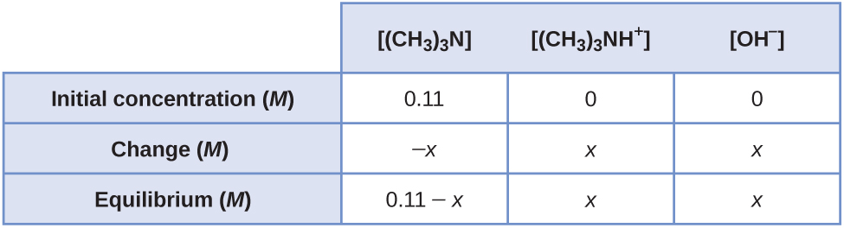

Substituting the equilibrium concentrations into the equilibrium expression and making the assumption that (0.11 – *x*) ≈ 0.11 gives:



Solving for *x* gives 2.63  10–3 *M*. This value is less than 5% of 0.11, so the assumption that it can be neglected is valid. Thus, the concentrations of solute species at equilibrium are:

 = [OH–] = 2.6  10–3 *M*

[(CH3)3N] = 0.11 – 2.63  10–3 = 0.107 = 0.11 *M*

;

(e) The reaction is:



The equilibrium expression is:



The initial and equilibrium concentrations for this system can be written as follows:

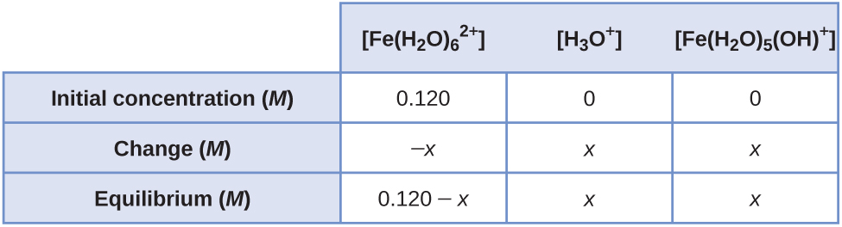

Substituting the equilibrium concentrations into the equilibrium expression and making the assumption that (0.120 – *x*) ≈0.120 gives:



Solving for *x* gives 1.39  10–4*M*. This value is less than 5% of 0.120, so the assumption that it can be neglected is valid. Thus, the concentrations of solute species at equilibrium are:

 =  = 1.4  10–4 *M*

= 0.120 – 1.39  10–4 = 0.1199 = 0.120 *M*



71. White vinegar is a 5.0% by mass solution of acetic acid in water. If the density of white vinegar is 1.007 g/cm3, what is the pH?

Solution

First, find the mass of acetic acid. *d* = 1.007 g/cm3. Take 1.0 L of solution to have the quantities on a mole basis. Then, since 1000 cm3 = 1.0 L, 1000 cm3  1.007 g/cm3 = 1007 g in 1.0 L. Then, 5.00% of this is the mass of acetic acid:



Now calculate the number of moles of acetic acid present. Themolar mass of acetic acid is 60.053 g/mol:



From the moles of acetic acid and *K*a, calculate :



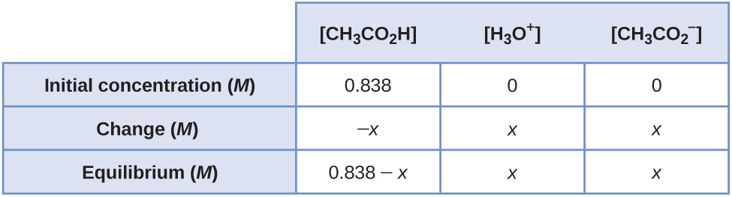

Substitution gives:



Drop *x* because it is small in comparison with 0.838 *M*.

*x*2 = 0.838(1.8  10–5) = 1.508  10–5 = 3.88  10–3 = 2.41

pH = –log(3.88  10–3) = 2.41

73. Nicotine, C10H14N2, is a base that will accept two protons (*K*1 = 7  10–7, *K*2 = 1.4  10–11). What is the concentration of each species present in a 0.050-*M* solution of nicotine?

Solution



First set up a concentration table:

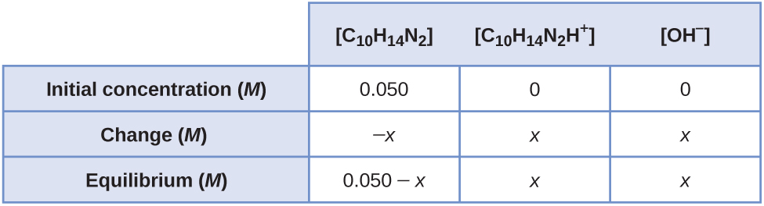

Substituting the equilibrium concentrations into the equilibrium equation and making the assumption that (0.050 – *x*) = 0.050, we get:



Solving for *x* gives1.87  10–4 = 2  10–4*M* = [OH–]

Because *x* is less than 5% of 0.050 and [OH–] is greater than 4.5  10–7*M*, our customary assumptions are justified. We can calculate [C10H14N2] = 0.050 – *x* = 0.050 – 2  10–4 = 0.048 *M*; [OH–] =  = *x* = 2  10–4*M*. Now calculate the concentration of in a solution with [OH–] and  equal to 2  10–4 *M*. The equilibrium between these species is . We know [C10H14N2H+] and [OH–], so we can calculate the concentration of  from the equilibrium expression:



The concentration of OH– produced in this ionization is equal to the concentration of, 1.4  10–11*M*, which is much smaller than the 2  10–4*M* produced in the first ionization; therefore, we are justified in neglecting the OH– formed from .

We can now calculate the concentration of H2O+ present from the ionization of water:

*K*a = 1  10–14 = [OH–]



We can now summarize the concentrations of all species in solution as follows:

[C10H14N2] = 0.049 *M*

= 1.9  10–4 *M*



[OH–] = 1.9  10–4 *M*

 = 5.3  10–11 *M*

75. The pH of a 0.15-*M* solution of  is 1.43. Determine *K*a for  from these data.

Solution

The reaction is .

The concentrations at equilibrium are +=  = 10–pH = 10–1.43 = 0.0372 *M*

[HF] = 0.15 – 0.0372 *M* = 0.113 *M*



77. The pH of a solution of household ammonia, a 0.950 *M* solution of NH3, is 11.612. Determine *K*b for NH3 from these data.

Solution

The reaction is .

The pOH can be determined from pOH = 14.000 – pH = 14.000 – 11.612 = 2.388. Therefore, the concentrations at equilibrium are + = [OH–] = 10–pOH = 10–2.388 = 0.004093 *M*

[NH3] = 0.950 – 0.004093 = 0.9459 *M*



This resource file is copyright 2015, Rice University. All Rights Reserved.